Jeonghyeon Woo

Space Op-Ed Essay

The election maps are used as the main indicator of election results since the maps can visualize the local results so that the viewers can grasp the overall result. However, the maps sometimes trick the viewers since the density is not shown.

The election map of 2016 is a good example. According to 270 to Win, Donald Trump won the election by electoral vote of 304 to 232, and the map below depicts the result[1].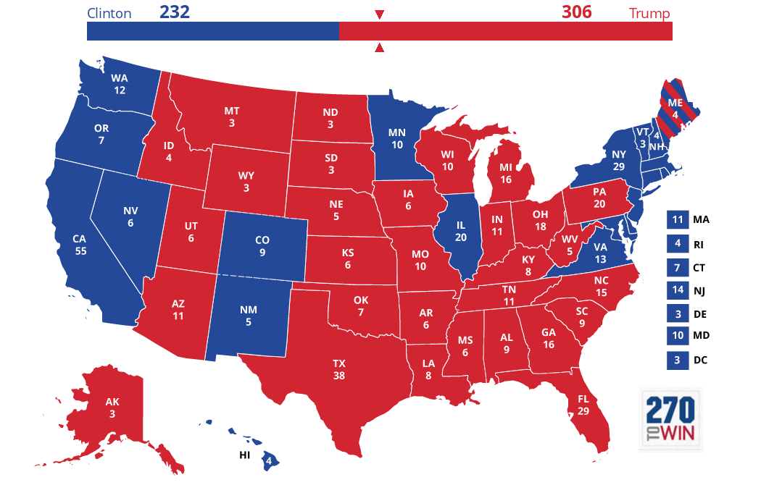

Figure : 270 to Win

The map shows that Trump won the election for the most states. However, there are some odd parts. For instance, Alaska is much bigger than Hawaii, but the number on Hawaii is bigger than the number on Alaska.

The leverage of regions is not applied to the map. Since the size of states are based on the real size of the states, the map can not illustrate how each state affected the election.

In addition, the ratio of winning is not depicted. For example, Clinton won by a landslide in California, and she barely won in Vermont, but both states have the same chroma. To depict the ratio of winning, California needs to be colored with dark blue and Vermont needs to be colored with light blue.

In fact, the map is intended to not show the leverage. The major intention of not showing the leverage is to make regional balance between states. If the map depicted the leverage, then some states would be overemphasized while the other states are disregarded.

As of Jan. 25th, 2014, Maptitude’s tumblr uploaded Kwon Kun’s map that depicts east Asia[2]. In the map, populated regions are well depicted, but unpopulated regions were omitted. Since the map was designed to show important regions, cites were emphasized by the intention.

The depiction contrasts with the election map. In the election map, the states are not emphasized by population but depicted by the actual size. The intention is to show all states are important.

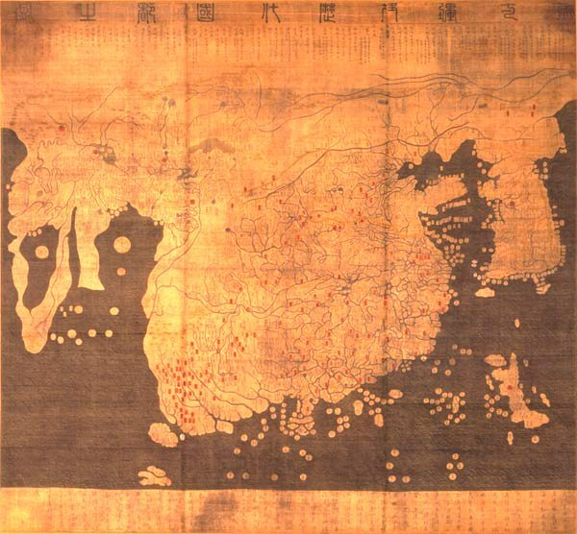

Figure : Kwon Kun

In the map “One World 1942” uploaded by radcalcartography, ally regions taken by axis are described as ally regions, and neutral regions taken by axis are described as neutral or pre-axis neutral region, so there are much more ally regions than axis regions[3]. In fact, axis soldiers controlled much more regions than shown. The map was designed to emphasize superiority of allies, so the regions have the same chroma to not show the exact influence of allies and axis on each regions.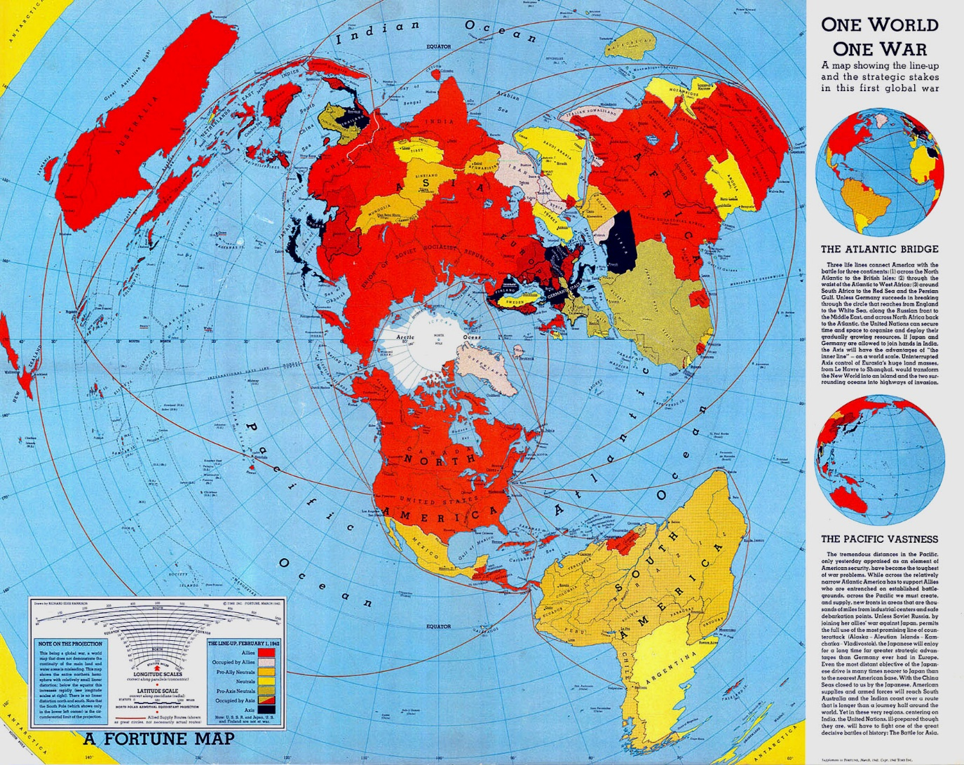

Figure : One World 1942

The election map has this kind of depiction. Though some regions were not much favorable to Trump, the map depicts that those regions are favorable to Trump as much as the other regions are favorable to Trump.

On the Pinterest, a map, “Wal Mart World Map”, was uploaded, and the map depicts China as the representative of Asian regions and the US as the representative of American regions[4]. The intention of the depiction is to keep the map simplified by showing representative.

In contrast, the election map depicts no representative. For example, the most people in California are living in the major cities such as LA, so the results of those major cities are more important than the results of the other cities, but the map does not depict neither LA nor San Francisco. The map is designed to show the overall result of the states, so cities are not depicted.

Since the president election in the US is done by electoral colleges, the population has less leverage on the election. In fact, Clinton’s total number of citizen votes were bigger than Trump’s. However, the most electoral colleges voted to Trump, so the result came out like the election map shows.

Therefore, the election maps don’t reflect the citizens’ vote. The maps are mainly designed to reflect the electoral colleges’ vote, so the maps don’t indicate the approval rate for the president.

**References**

“2016 Presidential Election Results”, 270 to Win, accessed Apr. 12, 2018, <https://www.270towin.com/maps/2016-actual-electoral-map>

“One World 1942”, radicalcartography, accessed Apr. 12, 2018, <http://www.radicalcartography.net/one-world-1942.jpg>

“Wal Mart World Map”, Pinterest, accessed Apr. 12, 2018,

<https://www.themappamundi.co.uk/mappa-mundi/>

“Kwon Kun”, Maptitude, accessed Apr. 12, 2018, <https://maptitude1.tumblr.com/image/74539323615>

1. 270 to Win, “2016 Presidential Election”.
2. Maptitude, “Kwon Kun”.
3. Radicalcartography, “One World 1942”.
4. Pinterest, “Wal Mart World Map”.